2- WebApi_Handson
We create the Web Api using .Net core with Swagger
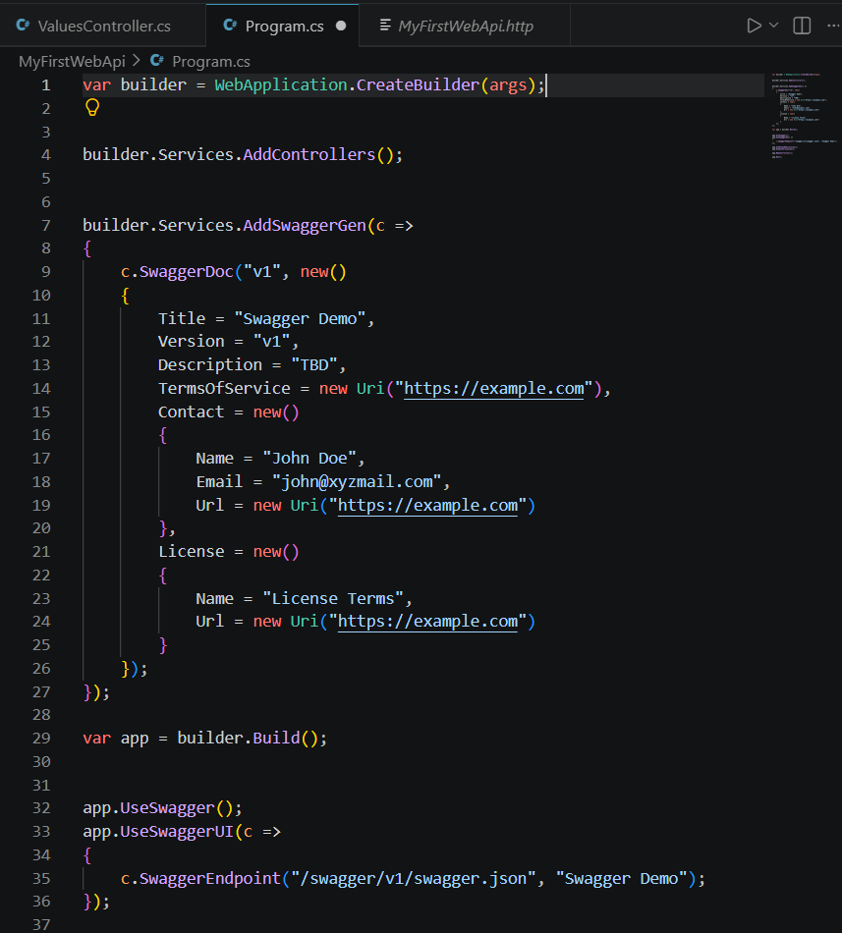
Here is the above code snippet.
And the output is shown here –
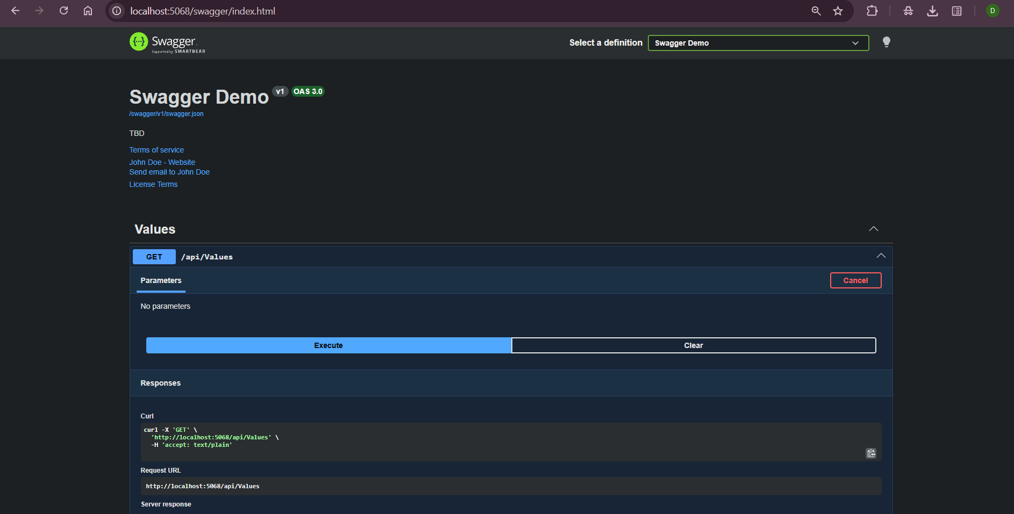
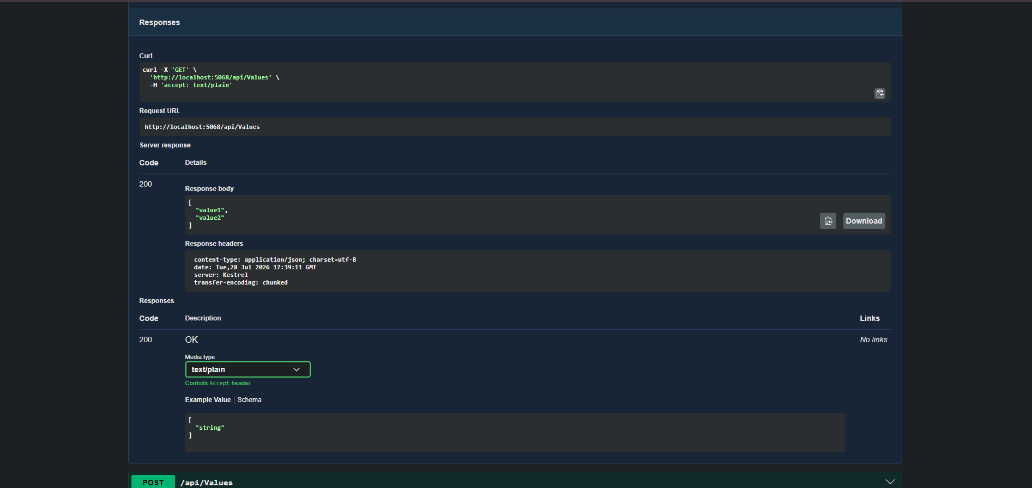
And now for step 2 output check –
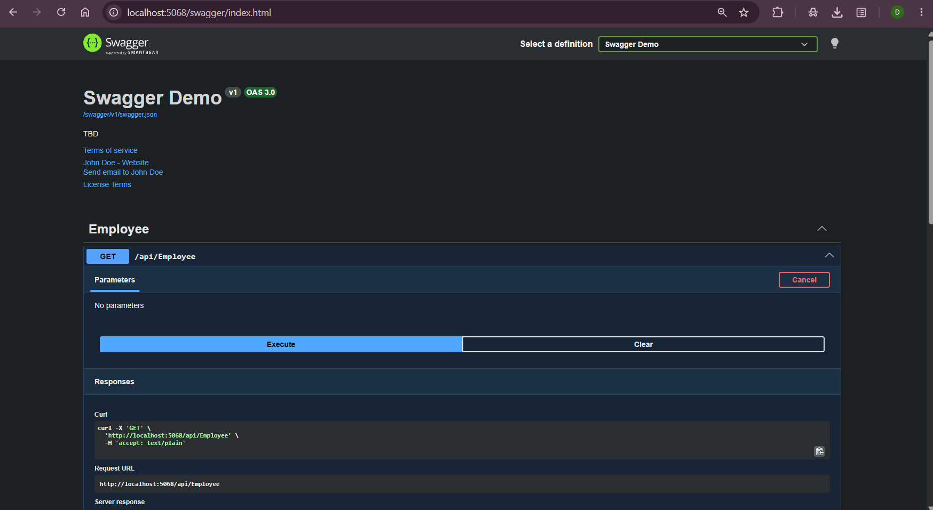
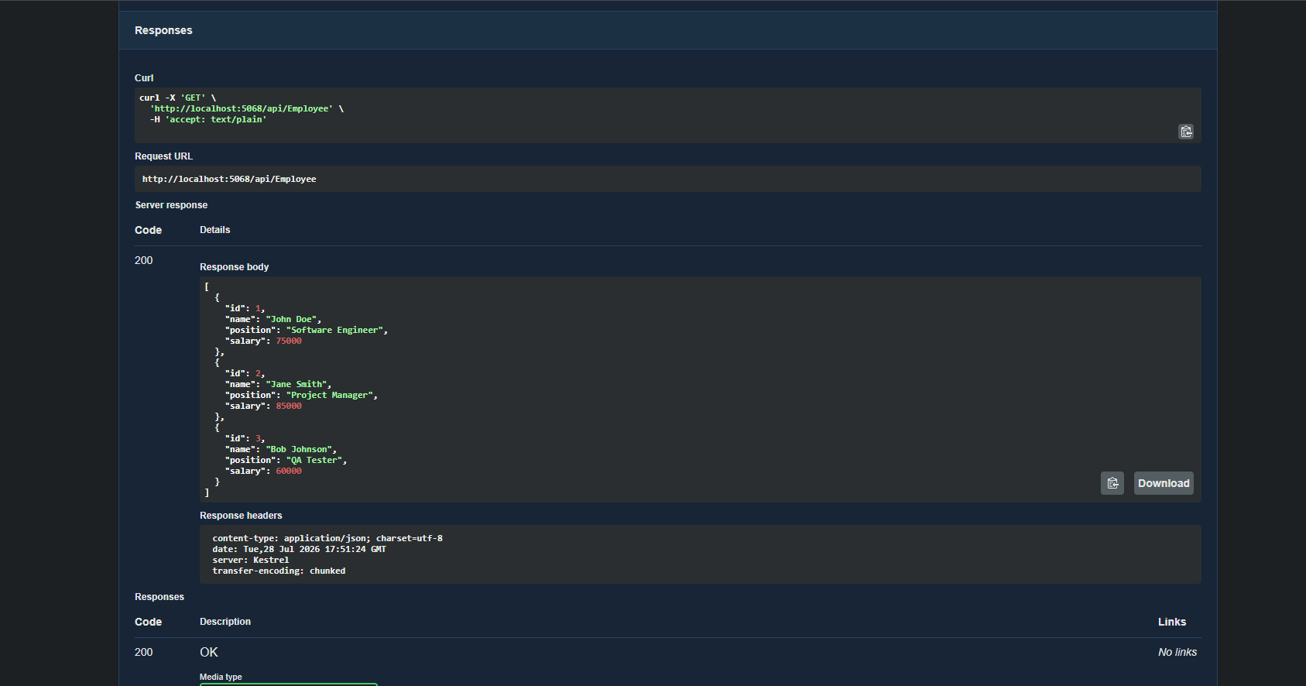
For step 3 we modify the Controller name in the Route attribute of the Employee controller to ‘Emp’ and check its access through POSTMAN
THE INPUT –
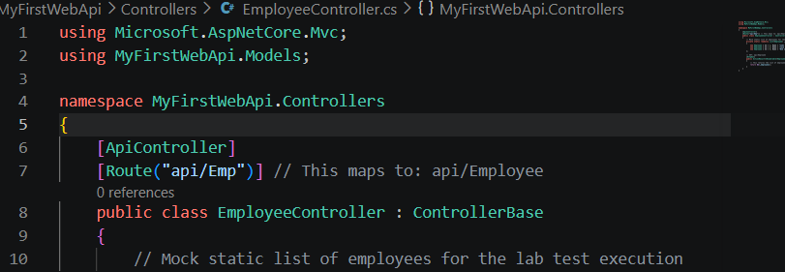
Modification as per the hands-on guide
THE OUTPUT –

